**NEWYORK STOCK MARKET**

Table of Contents

Section 1 3

1.1. Introduction 3

1.2. Background 3

1.3. Problem Statement 3

Section 2 4

2.1. Analysis 4

2.1.1. Data Exploration 4

2.1.2. Description of the Attributes 4

2.1.3. Results 5

Conclusion 7

References 8

# Section 1

## 1.1. Introduction

Data analytics has a great impact on many fields such as the business areas of marketing, finance, accounting and the management of the supply chain. In this article, the importance of big data for a business organization is discussed in different aspects. Big data analytics is very helpful for analyzing the resources of the company and allowing the best suitable decisions for their usage of them. After Covid, every organization has shifted their business online and the total offline data traffic shifted to online for this the business strategy for the process is totally rebuilt to tackle this. The usage of big datasets in the process of business work also increased and for that, the business process was also redeveloped.

## 1.2. Background

Data is a work that is totally dependent upon statistics and it is in use throughout the history of time such as the use in the building process of the pyramid of Egypt’s pyramid. Governments and different organizations are using it for planning and designing different economic activities, including the taxation system. In this process, the first stage for this is the collection of the data. The work of analyzing the population growth differentiated by the country and the city could allow the different locations of the new hospitals for the specific locations.

The research for the developments of computers and the evolution of computing technology changed totally after the implantation of data analytics in that field. The census of 1880 by us census bureau declared that they need eighteen years to complete the work and after this, Herman Hollerith developed a new technology that helped to analyze the same type of data using the tabulating machine’s punching card technology within the seven months; this is the first step for the development of the technology.

## 1.3. Problem Statement

The Stock Market is the location where different big investors invest their money to find and get the best returns on their investments. Big investment is always associated with big risks and for this; they take help from their financial advisors. This big dataset is prepared by financial analysts to show the proper position where the investment should be done. The following dataset is thirty per cent data of the excel data of the market. This big dataset has eleven attributes such as the tickers symbol, years, period end, total, costs of the gold sold and many more.

# Section 2

## 2.1. Analysis

Stock market data analysis is the method of studying and evaluating the data of the past and the present. Investors use the data of the stock market for analysis to make the decision when to purchase and when to sell their stock in the market; traders also use this type of analysis for their work. Investors use it before investing in a stock; it allows investors to understand the security of their investment in the market.

### 2.1.1. Data Exploration

The first and basic step for data analysis is data exploration; this feature allows users to explore the data and visualize them. This is a very important step for the starting of the analysis of the big datasets as the big datasets have many corrupted data containing the null value. This is also helpful for understanding the big data structure and going through the insight of the big datasets within the faster process (Kraus *et al.* 2020).

This is the dataset of the New York stock market and this dataset is prepared by the professional financial analysts of New York. This dataset is prepared in excel and it has a total of eleven attributes such as the ticker symbol, cost of the gold sold, total revenue and many more (Griva *et al.* 2018).

### 2.1.2. Description of the Attributes

The ticker symbol is a unique symbol that is generated by a series of letters and numbers for trading purposes. The stocks listed for the New York stock exchange have four or less than four numbers. This stock symbol's importance is that this is the short representation of the stock data for the company or the organization in the stock market; this stock symbol is also known as the ticker symbol.

The Cost of the gold sold is totally dependent upon the market price of the gold. When the market price is high the price of the gold share remains high and when the price is low the share price remains low (Duan *et al.* 2020). As gold is an important asset and the share remains always in a steady state, many investors choose this type of share for their investment (Ashrafi *et al.*  2019).

### 2.1.3. Results

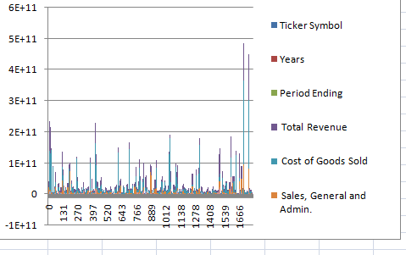

**Figure 1: bar graph of the different attributes**

(Source: Created in the Microsoft Excel)

This figure shows the analysis of the attributes of the complete dataset using the bar diagram or the graph and for that, all the collected data is tabulated in excel and the data of the excel file is used for the work. In this, the total revenue for the dataset is the highest most (Aydiner *et al.* 2019).

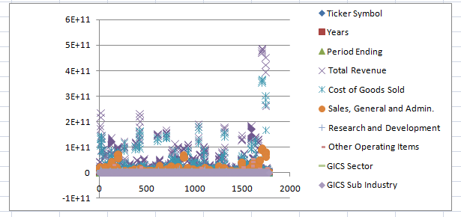

**Figure 2: Scatter plot of the different attributes**

(Source: Created in the Microsoft Excel)

This figure shows the scatter plot of the different attributes of the dataset; the scatter plot is generated to identify the corrupted or the null data of the different attributes of the datasets.

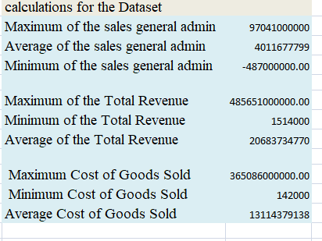

**Figure 3: Important calculations for the dataset**

(Source: Created in the Microsoft Excel)

This is the calculation of the datasets required for the investment in the share market of New York. In this calculation different attributes data for the sales, revenue and cost of the gold sold are prepared (Pappas *et al.* 2018). Here MIN, MAX, AVG functions are used. The MIN function refers to the lowest feasible number in the given set of data, the same pertains to the max function, but it includes highest feasible number. This helps use to compare the results and find out which area has the best results and helps business persons to invest in it.

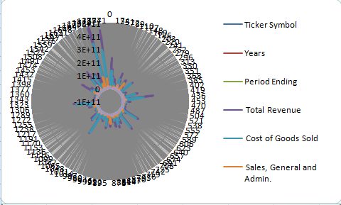

**Figure 4: Radar representation of the attributes**

(Source: Created in the Microsoft Excel)

In the figure, the radar representation for the attributes of the dataset is prepared in Microsoft excel. The radar representation is helpful to show the relations of the dataset and for this purpose, the graph is prepared.

# The results shows that gold is a reliable source to invest upon if some one wants to start an investment, even though the price of gold depends upon the market value, it will not affect the investor even if the price has dropped as others would affect if they are not doing well. That is the reason most of the financial advisors say that gold is dead investment which means if you invest on it once, you do not have to check it again and again, no matter what one should incur profits.

# Conclusion

In this work, the business analytics for the following dataset is prepared to show the important point for investing in the New York Stock market. In this work, the graph and the diagrams of the dataset are prepared also in the Microsoft excel. In this project even though the sector that is more profitable is selected, this compares only the businesses not other professions in life. Only some fields are compared. Also, while calculating, it could be possible that that the data might be wrong that is given by the business institutions. In the future it can be made such that not only gold but also other aspects as well.

# References

Ashrafi, A., Ravasan, A.Z., Trkman, P. and Afshari, S., 2019. The role of business analytics capabilities in bolstering firms’ agility and performance. International Journal of Information Management, 47, pp.1-15.

Aydiner, A.S., Tatoglu, E., Bayraktar, E., Zaim, S. and Delen, D., 2019. Business analytics and firm performance: The mediating role of business process performance. Journal of business research, 96, pp.228-237.

Duan, Y., Cao, G. and Edwards, J.S., 2020. Understanding the impact of business analytics on innovation. European Journal of Operational Research, 281(3), pp.673-686.

Griva, A., Bardaki, C., Pramatari, K. and Papakiriakopoulos, D., 2018. Retail business analytics: Customer visit segmentation using market basket data. Expert Systems with Applications, 100, pp.1-16.

Kraus, M., Feuerriegel, S. and Oztekin, A., 2020. Deep learning in business analytics and operations research: Models, applications and managerial implications. European Journal of Operational Research, 281(3), pp.628-641.

Pappas, I.O., Mikalef, P., Giannakos, M.N., Krogstie, J. and Lekakos, G., 2018. Big data and business analytics ecosystems: paving the way towards digital transformation and sustainable societies. Information Systems and e-Business Management, 16(3), pp.479-491.